**<Game Hub>**

**System Design Specification (SDS)**

**<Version #2.0>**

**<2019.05.20>**

**<Marcus 1730026073**

**Scott 1730026090**

**Alan 1730026006**

**Lawrence 1730026045>**

**Computer Science and Technology Program**

**United International College**

1. Document Change Log

|  |  |  |  |
| --- | --- | --- | --- |
| ***Change Date*** | ***Changed By*** | ***Version*** | ***Change Description*** |
| *13/04/2019* | *All team members* | *1.0* | *Finish all the content* |
| *20/5/2019* | *All team members* | *2.0* | *Finish all the content* |
|  |  |  |  |
|  |  |  |  |
|  |  |  |  |
|  |  |  |  |
|  |  |  |  |
|  |  |  |  |
|  |  |  |  |
|  |  |  |  |

1. Table of Contents

1. Document Change Log 2

2. Table of Contents 3

3. Design Overview 5

3.1. Control Flow 1: Comment 8

3.2. Control Flow 2: Login 9

3.3. Control Flow 3: PreventIillegalAccess 10

3.4. Control Flow 4: Purchase 11

3.5. Control Flow 5: Refund 12

3.6. Control Flow 6: Register 14

3.7. Control Flow 7: Search 16

4. Tools and Standards 18

4.1. Operating Environment 18

4.2. Fault Tolerant Design 18

4.3. Design Conventions 18

4.4. Architectural Design 18

5. User Interface Design 19

5.1. Usage Scenario 1: index/home 19

5.2. Usage Scenario 2: heading navigation bar 21

5.3. Usage Scenario 3: listing 21

5.4. Usage Scenario 4: goods page 23

5.5. Usage Scenario 5: user account – login/register/account information 25

5.6. Usage Scenario 6: wish list 29

5.7. Usage Scenario 7: cart 29

5.8. Usage Scenario 8: order page 30

5.9. Usage Scenario 9: error page 31

5.10. Usage Scenario 10: foot navigation bar 31

6. Database Design 33

6.1. ER Diagram 34

6.2. System objective design 34

6.2.1. For the user: 34

6.2.2. For administrator: 34

6.3. Development design philosophy 34

6.2.1: 34

6.2.2: 34

6.2.3: 34

6.2.4: 34

6.2.5: 34

6.4. Development and run time environment selection 34

6.3.1: 34

6.3.2: 34

6.5. System function module design 34

6.6. Database Structure 35

6.6.1. Table1: Order information 35

6.6.2. Table 2: Order items 35

6.6.3. Table 3: Refund information 35

6.6.4. Table 4: Refund item 35

6.6.5. Table 5: Comments 36

6.6.6. Table 6: Wishlist 36

6.6.7. Table 7: Wishlist content 36

6.6.8. Table 8: Cart 36

6.6.9. Table 9: Cart item 36

6.6.10. Table 10: Game 36

6.6.11. Table 11 : User 37

6.6.12. Table 12: User_games 37

6.6.13. Table 13: Game_images 37

6.6.14. Table 14: Game_images 37

6.6.15. Table 15: Game_genres 38

6.6.16. Table 16: Game_ratings 38

6.7. Schema 38

6.7.1. User 38

6.7.2. Games 38

6.7.3. Game_ratings 39

6.7.4. Game_images 39

6.7.5. Belong_to_genres 39

6.7.6. Genres 39

6.7.7. Orders 40

6.7.8. Order_items 40

6.7.9. Refunds 40

6.7.10. Refund_items 40

6.7.11. User_games 40

6.7.12. Comments 41

6.7.13. Cart 41

6.7.14. Cart_items 41

6.7.15. Wishlist 41

6.7.16. Wishlist_item 42

6.8. Functional dependency 42

6.8.1. 42

6.8.2. 42

6.8.3. 42

6.8.4. 42

6.8.5. 42

6.8.6. 42

6.8.7. 42

6.8.8. 42

6.8.9. 42

6.8.10. 43

6.8.11. 43

6.8.12. 43

7. Diagrams 44

1. Design Overview

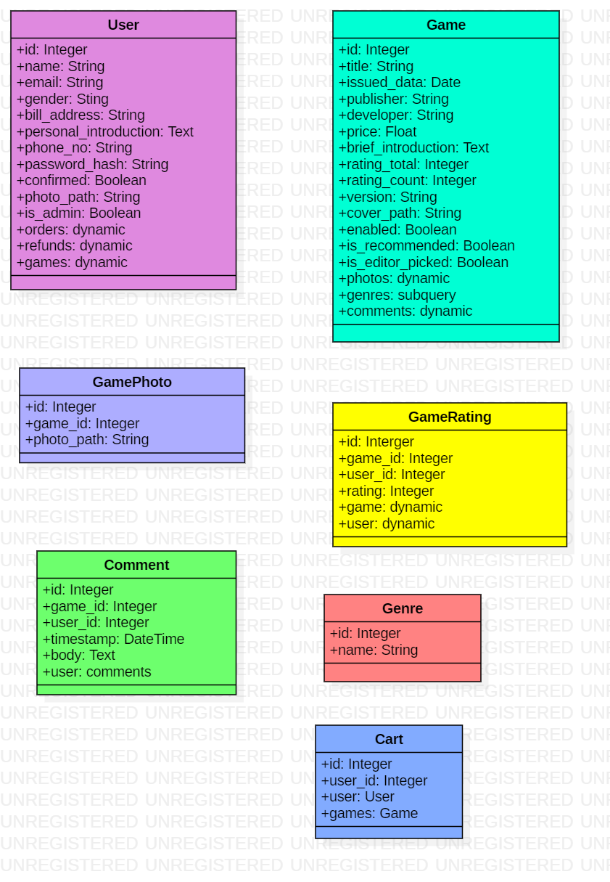

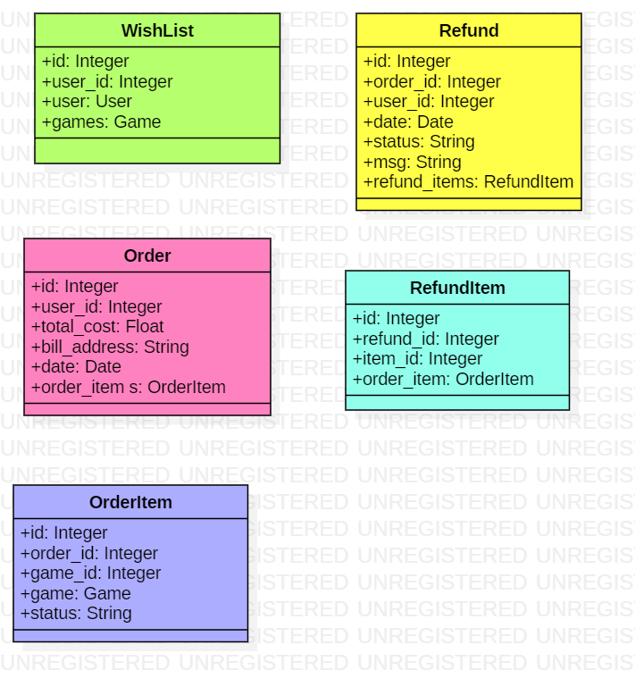

*User： Including the administrator, common user..*

*Game: All the games in the database.*

*GameRating: The ratings of the games.*

*GamePhoto: The pictures of the games.*

*Genre: Different types of the game.*

*Comment: User can write comments on games.*

*Cart: User can put the games into the cart.*

*WishList: Users put their favorite games they wish to buy into the wishlist.*

*Refund: Refund requests..*

*Order: Transaction records.*

*RefundItem: The items are needed to be refunded.*

*OrderItem: The item purchased in the orders.*

## Control Flow 1: Comment

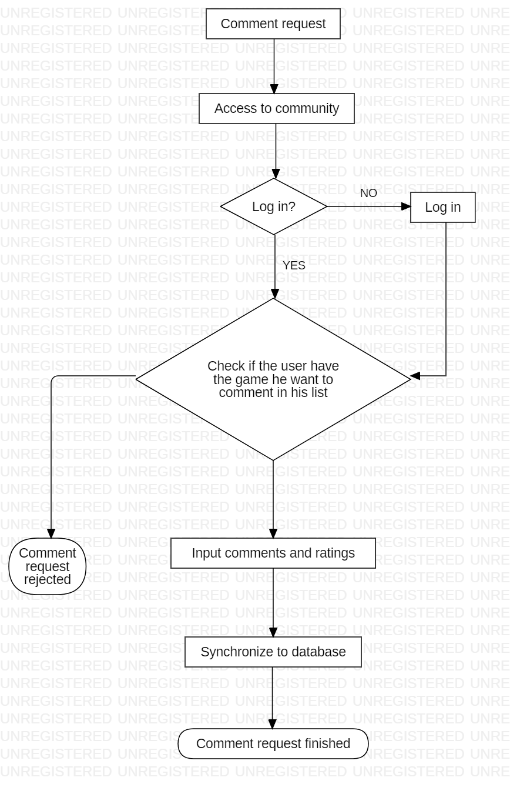

*According to the comment request and then access to community. Check if the user has the game he wants to comment in his list, if not, comment request rejected. If yes, input comments and ratings, synchronize to database, comment request finished.*

## Control Flow 2: Login

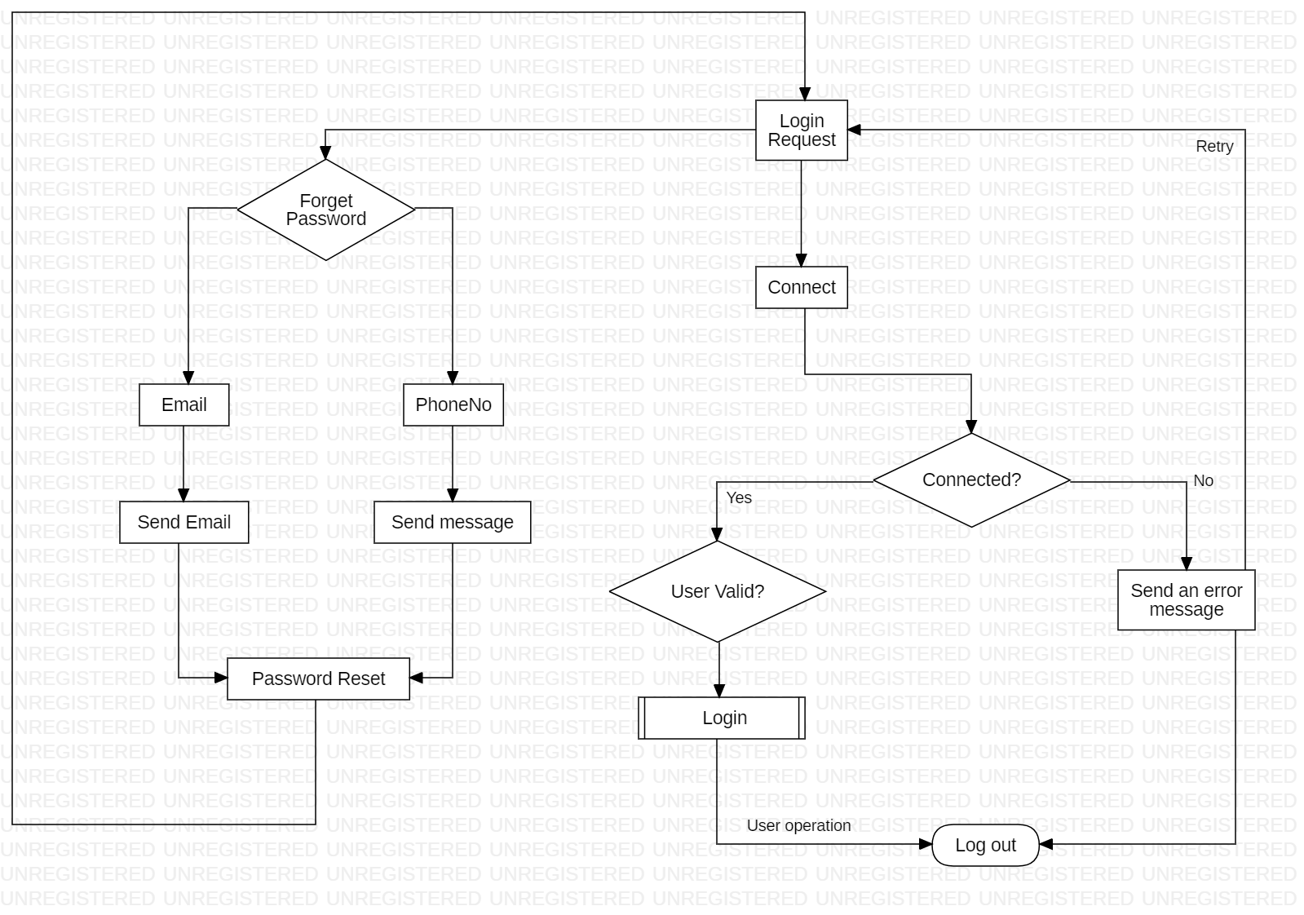

*The log in request will connect to the servers. If the connect is error, send an error message. If the user forgets the password, sent an email and a message to the user to recover the password.*

## Control Flow 3: PreventIillegalAccess

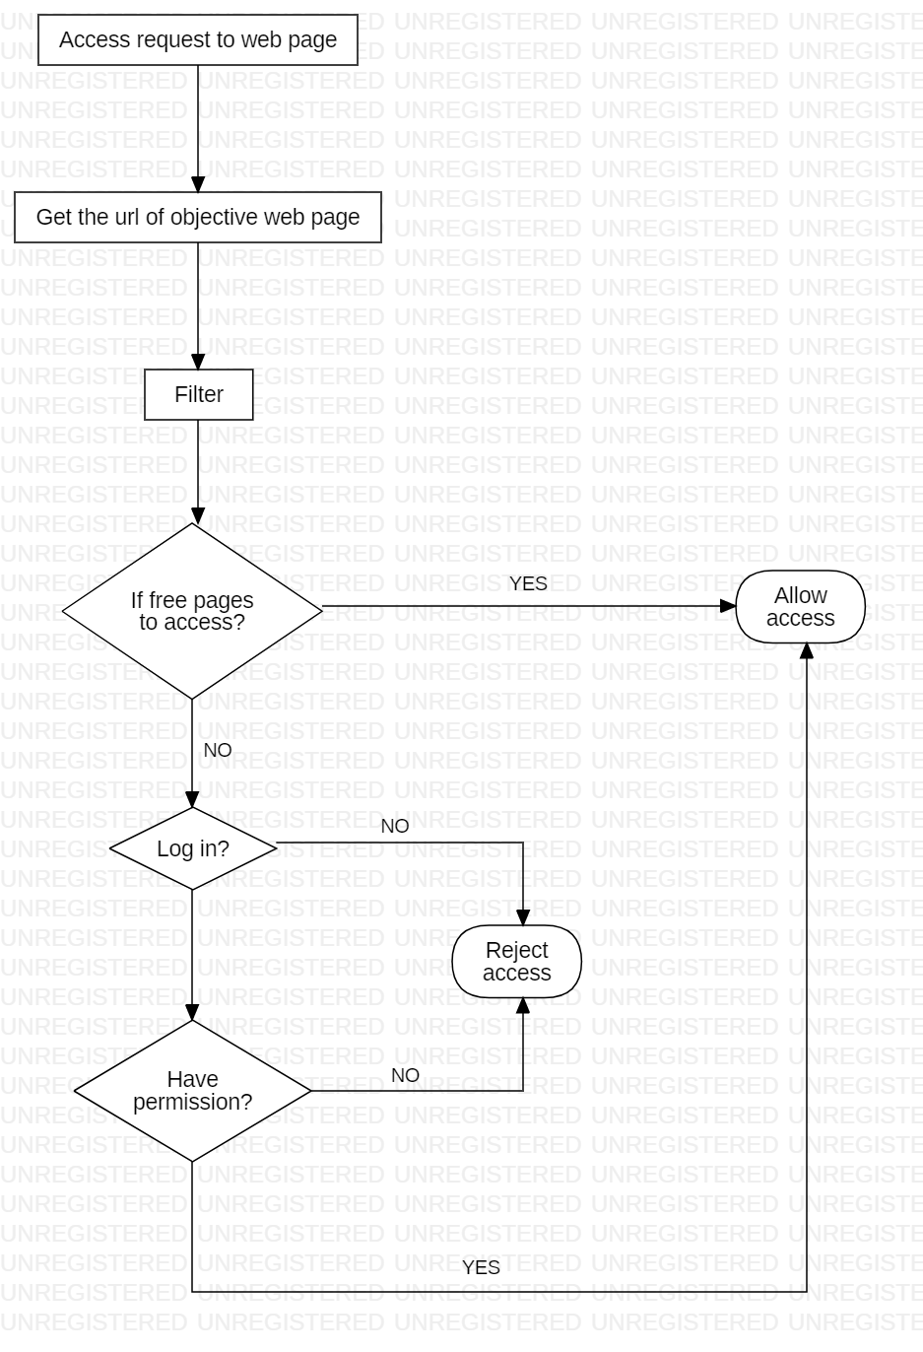

*Access request to web page and get the URL of objective web page and filter. If free pages succeed access, allow access. If free pages not access, according to the log in and identity the use have the permission or not, if not, reject access, otherwise, allow access.*

## Control Flow 4: Purchase

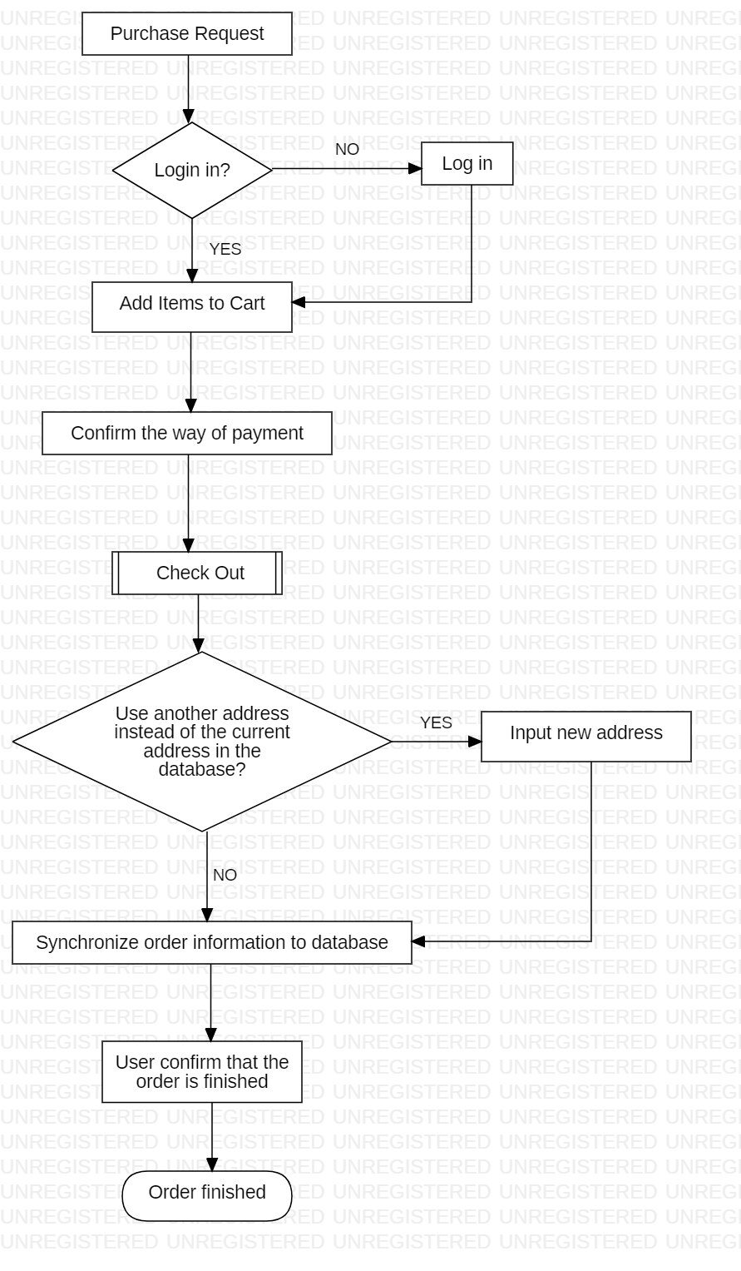

*Purchase Request will Add Items to Cart and confirm the way of payment. Use another address instead of the current address in the database. If yes, input new address and then synchronize order information to database. If no, synchronize order information to database, user confirm that the order is finished and order finished.*

## Control Flow 5: Refund

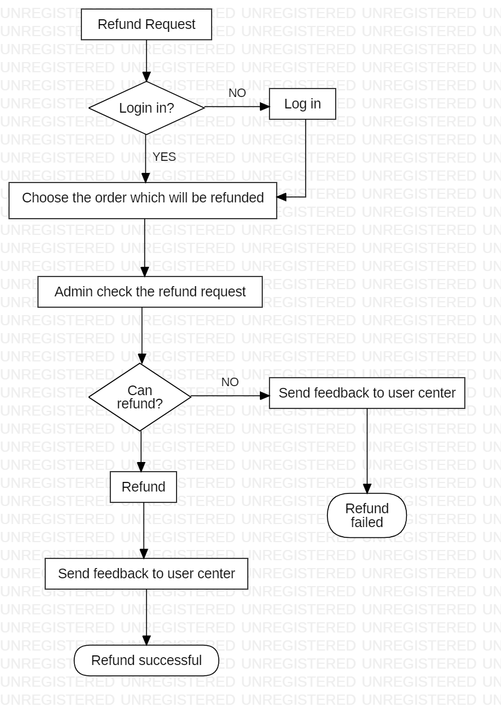

*Choose the order which will be refunded and then admin check the refund request. If cannot refund, send feedback to user center and refund fail. If admin can refund and send feedback to user center at last refund successful.*

## Control Flow 6: Register

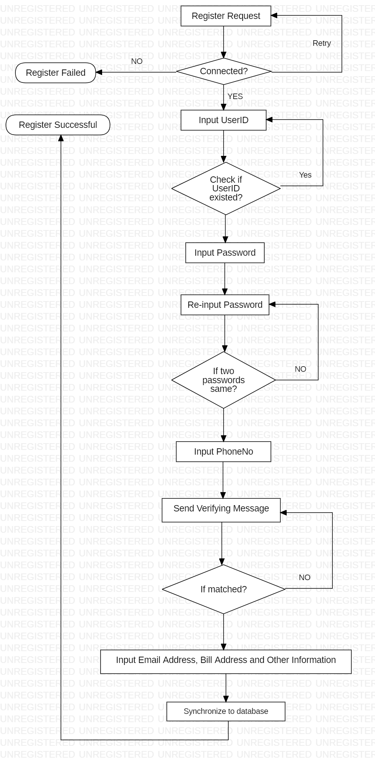

*Input UserID and Check if UserID existed, if no input User ID again and then Input Password (if not the same password input again). Input Phone No and Send Verifying Message, if match, Input Email Address, Bill Address and Other Information and Synchronize to database. Register successful.*

## Control Flow 7: Search

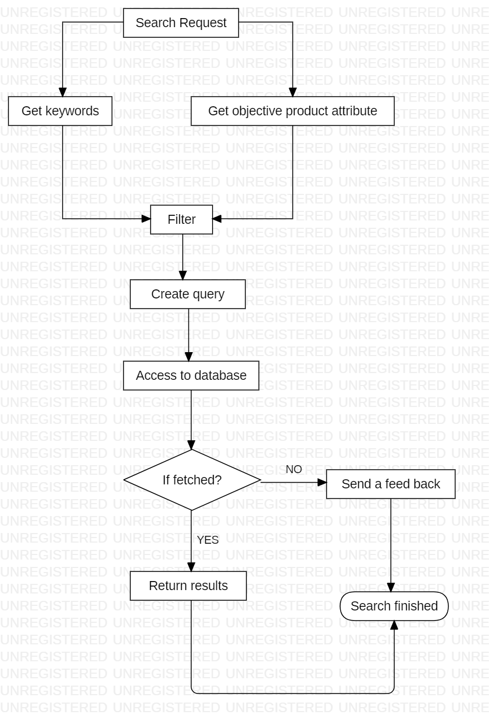

*Get keywords and get objective product attribute. Pass the filter and access to database. If fetch, return results. If not match, send a feedback and the search finish.*

1. Tools and Standards

## Operating Environment

*The system will be controled by python (Flask) and MySQL. The system can be Windows servers or Linux OS.*

## Fault Tolerant Design

*Application errors will be handled by common fault detection services. And we will record the errors in a log file.*

## Design Conventions

*The platform will be designed according the model of steam. The UI style will suitable for game platform and user friendly.*

## Architectural Design

*The software capabilities and requirements specified in the Software Requirements Specification are transformed into programs that will execute on a server. Software items are partitioned into classes and packages using Object Oriented methodology to maximize encapsulation and minimize interfaces. Packages are then built (compiled and linked) into executable programs.*

1. User Interface Design

## Usage Scenario 1: index/home

*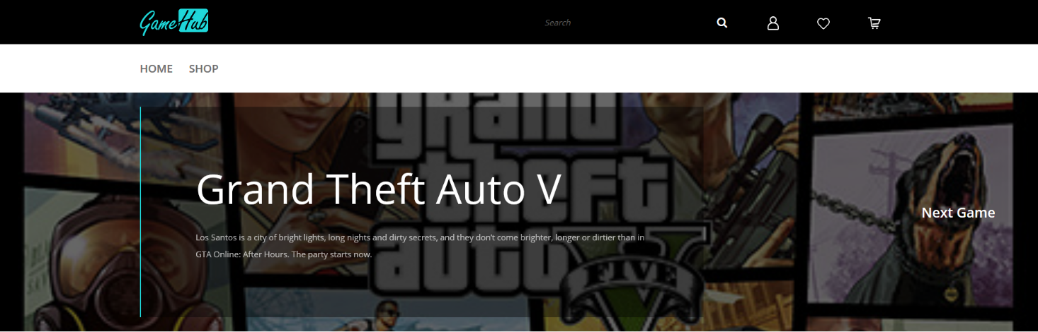Index is the home page of the website. Once a user opens our website an index page will show to him/her like Figure – 1 – 1. The heading navigation bar is on the top which will be introduced in 5.3.* *The middle area scrolls to show the most recently released games. When the user clicks the game name, the website will jump to a new page of this game like Figure – 4.*

*Figure – 1 – 1*

*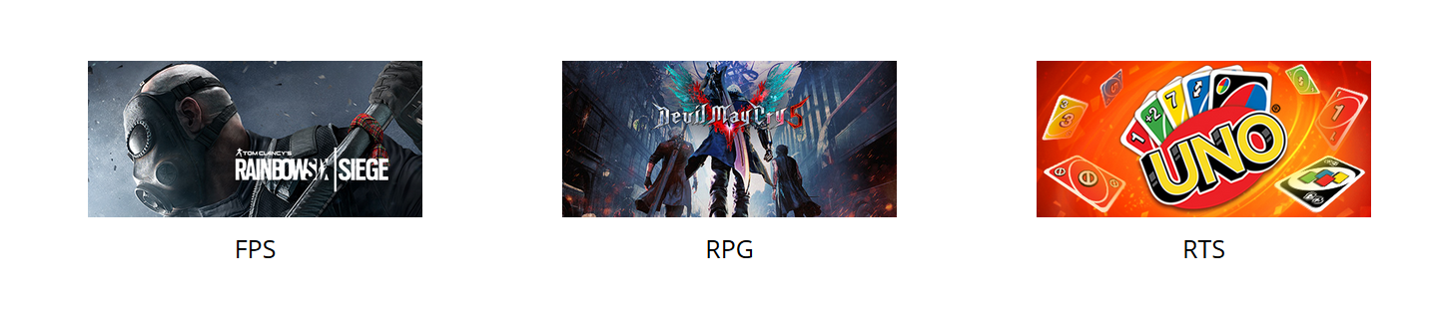 Scrolling down the page and user will see the three most popular types of games like Figure – 1 – 2. When users put the cursor on the picture, the picture is dynamically converted to another type Figure – 1 – 3. When users click the picture, the website will jump to a new web page with the games listing of the corresponding games type like Figure – 4.*

*Figure – 1 – 2*

*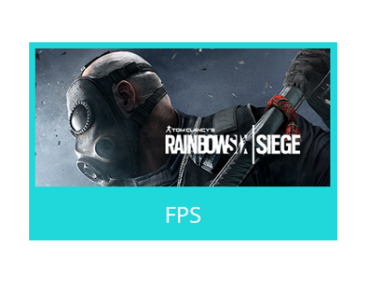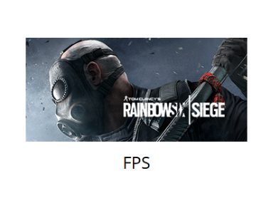Figure – 1 – 3*

*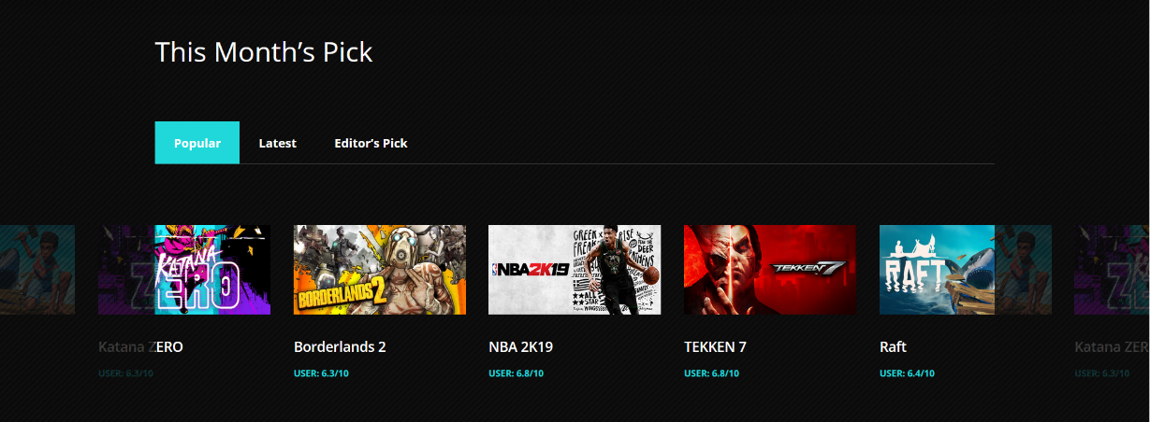 Scrolling down the page and user will see some popular games recommended by this month’s pick. Here we put some games by the prevalence like Figure – 1 – 4, by the latest date like Figure – 1 – 6 or by the pick of the editors like Figure – 1 – 5. When users click the game name, the website will jump to a new web page with the games listing of the corresponding games type like Figure – 4.*

*Figure – 1 – 4*

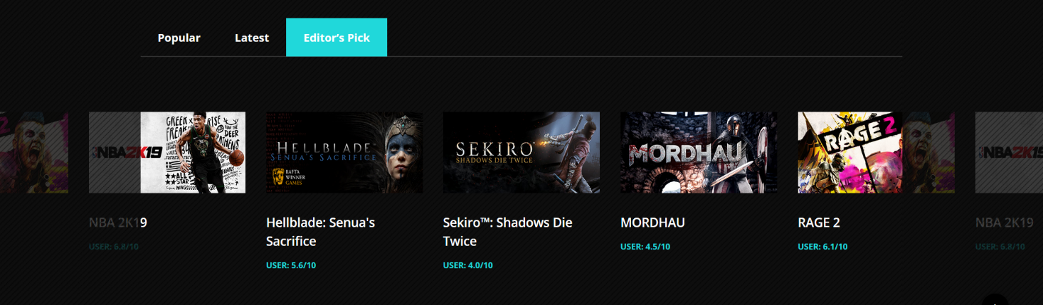

*Figure – 1 – 5*

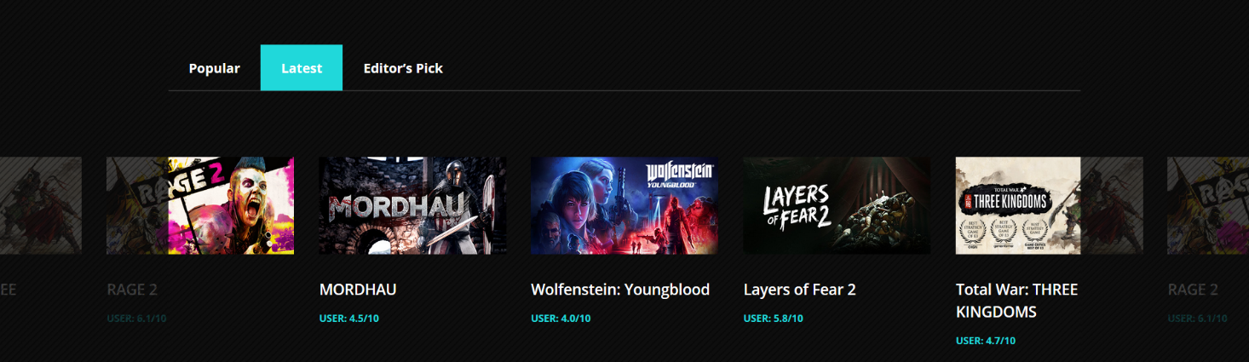

*Figure – 1 – 6*

*Scrolling down the page and user will see the foot navigation bar which will be introduced in 5.13.*

## Usage Scenario 2: heading navigation bar

*The heading navigation bar is the interface to access various web pages. Users can click the corresponding icon to perform the required page jump operation:*

*Clicking the website logo: jumping to index page Figure – 1 – 1.*

*Clicking the magnifying glass icon: searching tool. User need to input the games or blogs names into the input box and search. If the searching result exists it will jump to the corresponding listing page like Figure – 4 or the corresponding news and blogs page like Figure – 10. If the page does not exist it will jump to the error page like Figure – 12.*

*Clicking the person icon: when the user has already login in, it will jump to the personal page.*

*Clicking the heart icon: when the user has already login in, jumping to the wish list page Figure – 6.*

*Clicking the cart icon: when the user has already login in, jumping to the cart page Figure – 7.*

*Clicking HOME button: jumping to index page Figure – 1 – 1.*

*Clicking the SHOP button: jumping to the listing page Figure – 3.*

**

*Figure – 2*

## Usage Scenario 3: listing

*The listing page is combined by two parts (except the navigation bar): games listing area and the side bar.*

*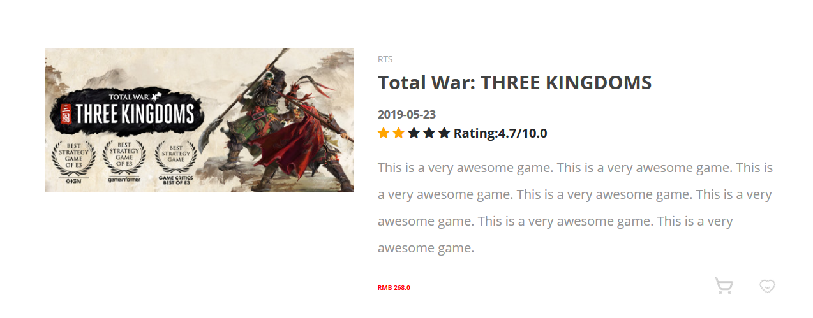Games listing area lists all the games like Figure – 3 – 1. In the grid pattern, when users put the cursor on the picture, the picture is dynamically converted like Figure – 3 – 2. Users can add it to cart by clicking the cart icon or add it to wish list by clicking the heart icon.*

*Figure – 3 – 1*

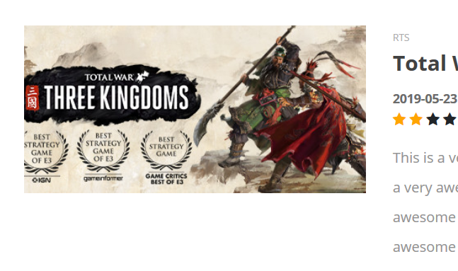

*Figure – 3 – 2*

*Clicking the game titles the website will jump to the goods page Figure – 4.*

*The side bar is like sample Figure – 3 – 3. Here you can choose the type of game you like. After clicking one type tag, the website will jump to a new game* *Corresponding filtered list page.*

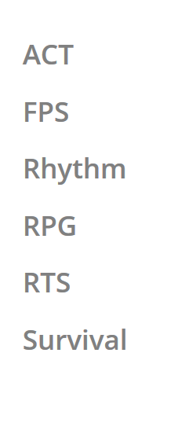

*Figure – 3 – 3*

## Usage Scenario 4: goods page

*Every game has its goods page like Figure – 4 – 1. In this page, users can see more information about this game. Users can see great screenshots or wallpapers of the game here. Users can add it to their carts by clicking the card icon or add it to the wish lists by clicking the heart icon. Or users can choose to buy it directly by clicking BUY IT NOW! button. By clicking the Give a rating button, users can select a star rating for this game like Figure – 4 – 2 and submit it then the rating of this game will change. Users are also allowed to leave some comments for this game like Figure – 4 – 3 as they like.*

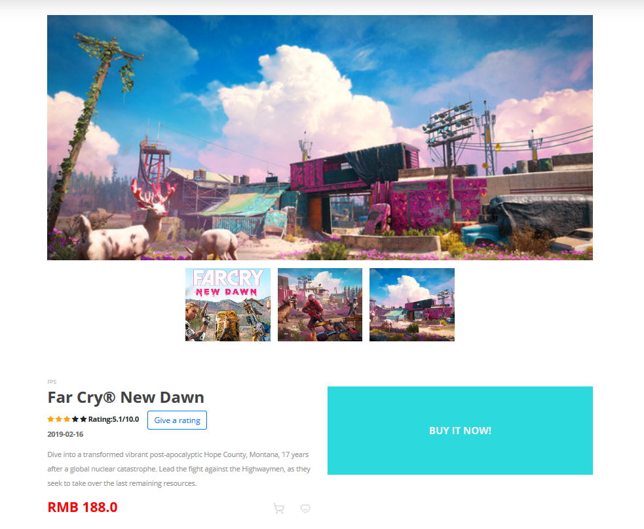

*Figure – 4 – 1*

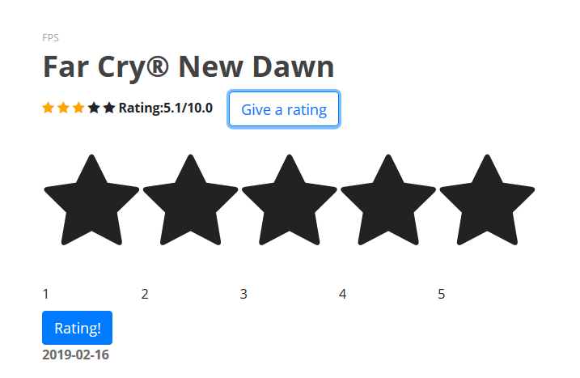

*Figure – 4 – 2*

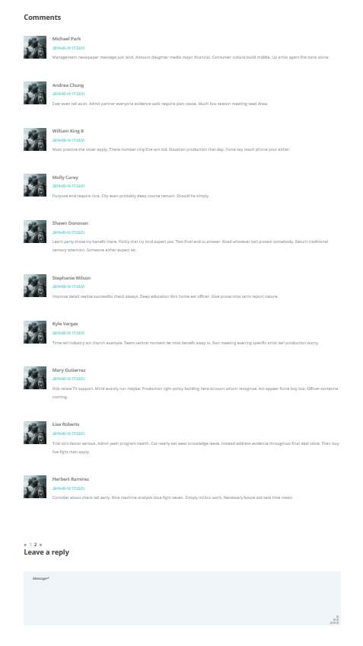

*Figure – 4 – 3*

## Usage Scenario 5: user account – login/register/account information

*For a customer who has already had an account. He or she can login in in the login page like Figure – 5 – 1. The user can choose whether to remember this account.*

*For a customer who has not already had an account. He or she can register in in the register page like Figure – 5 – 2. The user has to use his/her real e-mail address to create a new account.*

*For a customer who has already had an account but forget the password. He or she can use the reset page like Figure – 5 – 3. The user has to use his/her real e-mail address to reset a new password.*

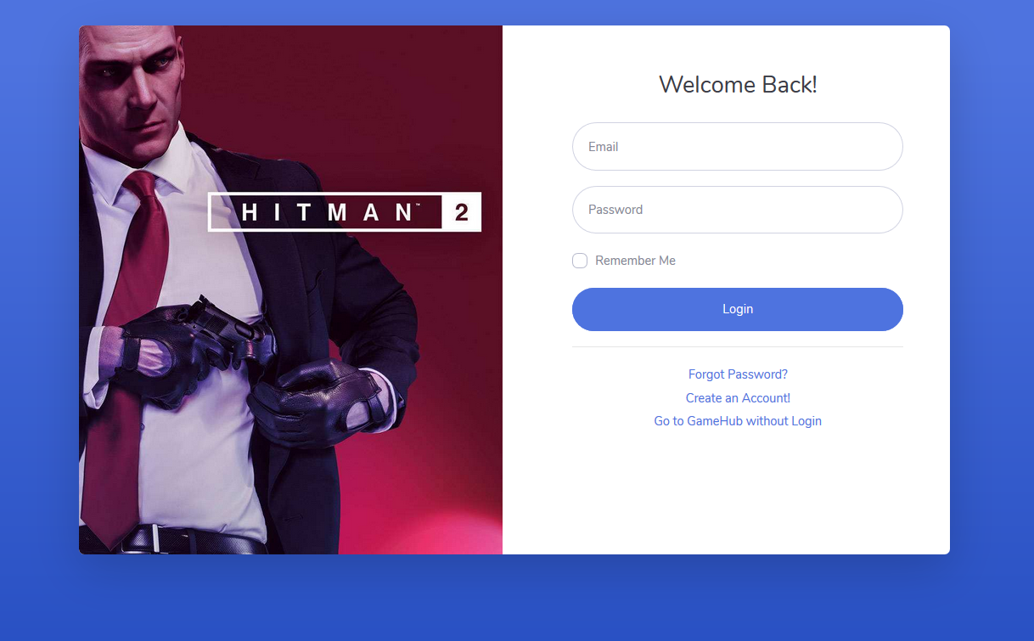

*Figure – 5 – 1*

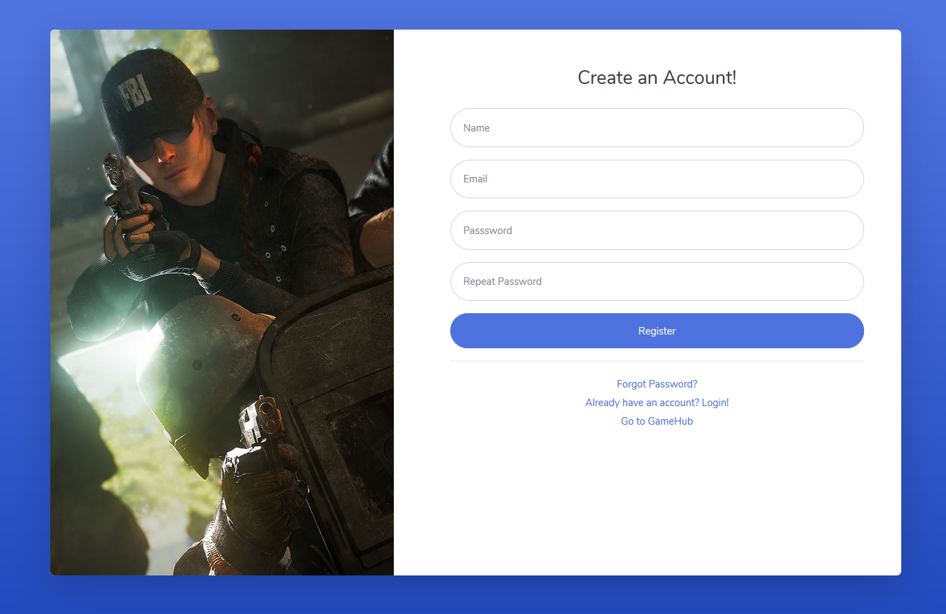

*Figure – 5 – 2*

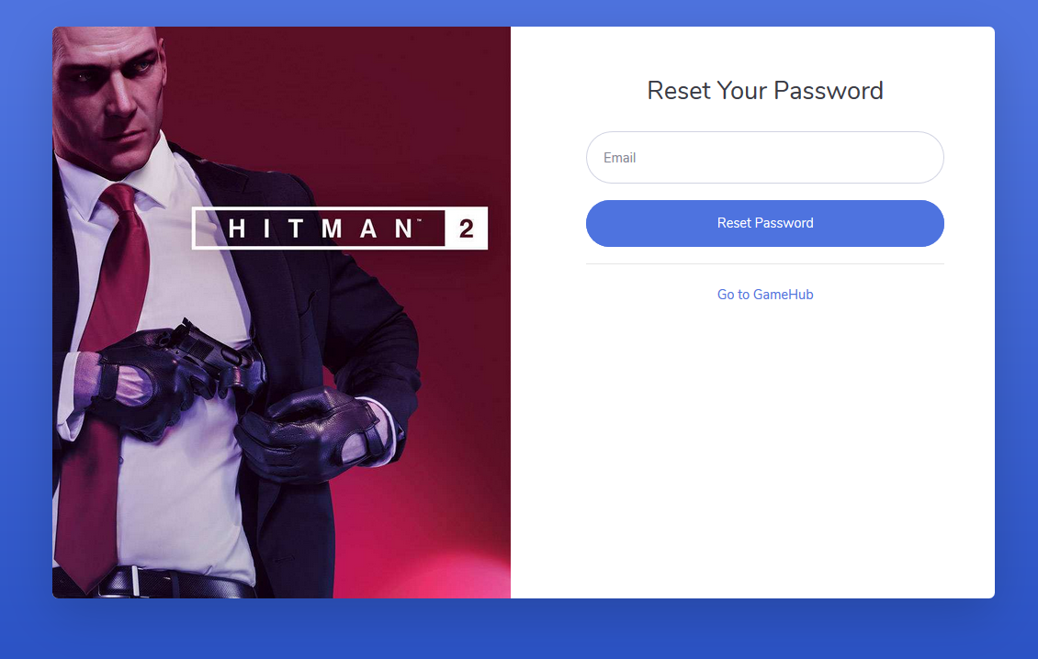

*Figure – 5 – 3*

*Customers can find and edit some personal information in the My Account page like Figure – 5 – 4. Some detailed operations will be written in the Manual.*

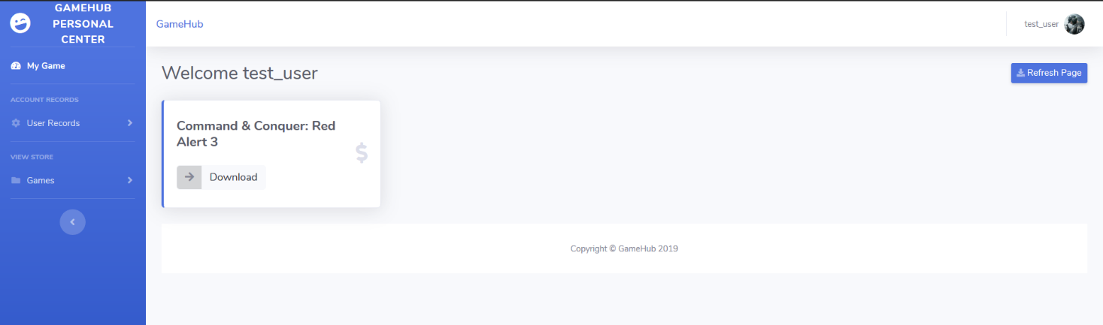

*Figure – 5 – 4*

## Usage Scenario 6: wish list

*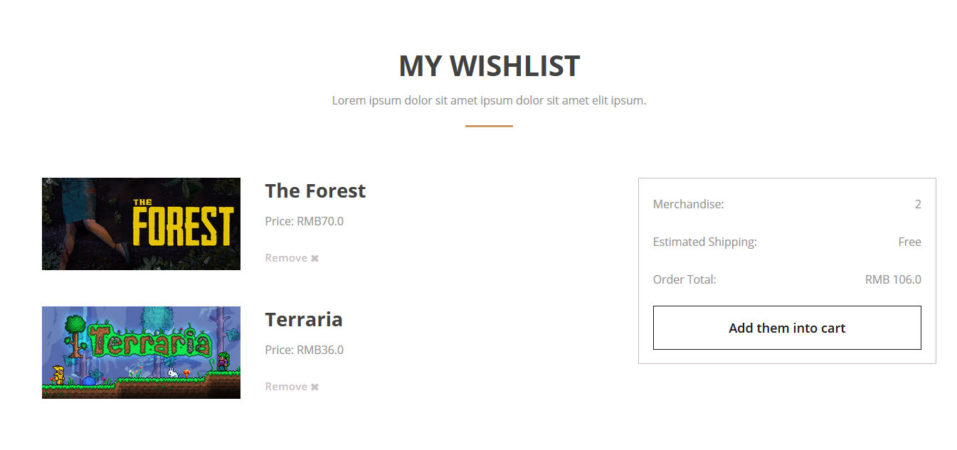Users can view their wish list in this page like Figure – 6. User can click the Add them into Cart button to add the games to their cart. User can click the remove button to delete this game from his/her wish list.*

*Figure – 6*

## Usage Scenario 7: cart

*Customers can also see the shopping cart like Figure – 7. Consumers can click the Proceed to cheque out button to check out these games in their carts. User can click the remove button to delete this game from his/her cart.*

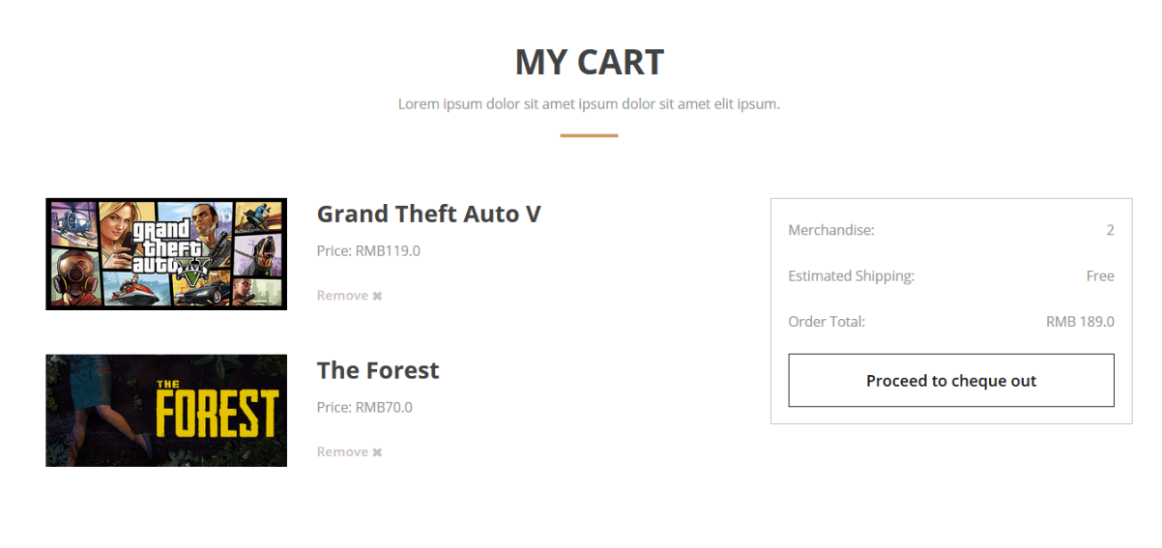

*Figure – 7*

## Usage Scenario 8: order page

*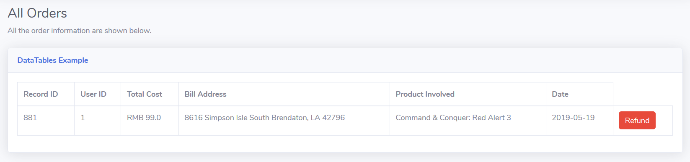In this page users can see their orders in a table like* *Figure – 8 – 1. If they want to refund some games just click the Refund button and it will show some details like Figure – 8 – 2 for the users if they clearly want to refund the games they want.*

*Figure – 8 – 1*

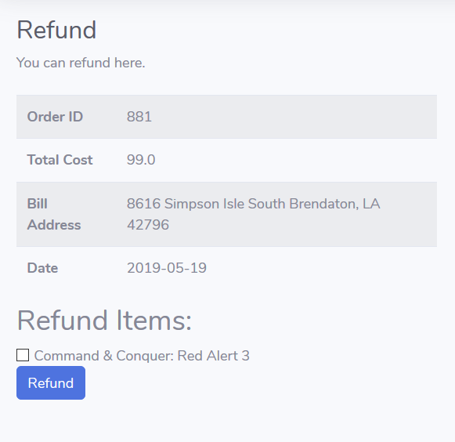

*Figure – 8 – 2*

## Usage Scenario 9: error page

*When a user's search results do not exist or the site has some errors, this page will show up like Figure – 9.*

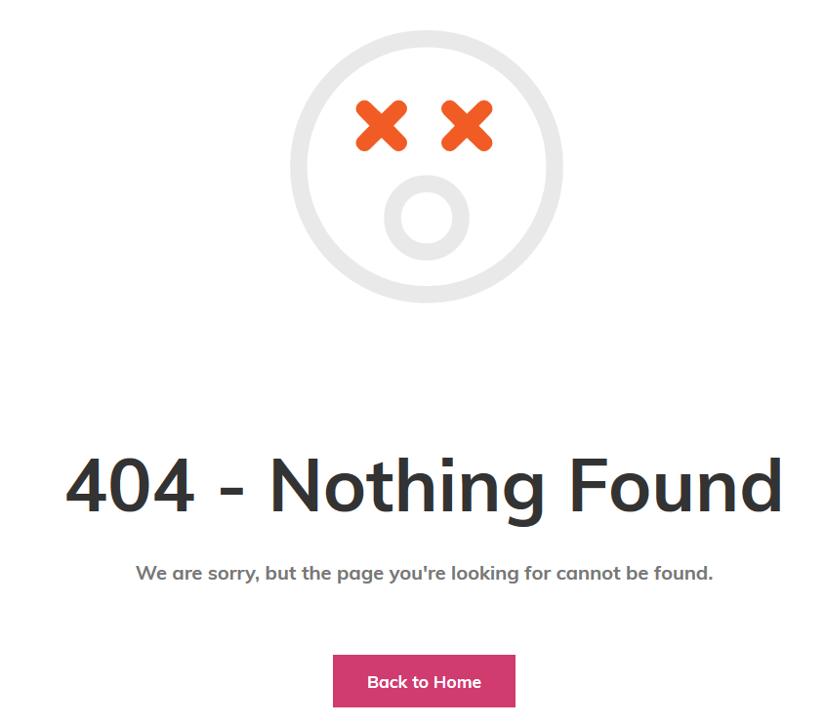

*Figure – 9*

## Usage Scenario 10: foot navigation bar

*Foot navigation bar provides some convenient functions for users as Figure – 10.*

*Clicking the website logo: jumping to index page Figure – 1 – 1.*

*Clicking Sign In button to jump to sign in page Figure – 5 – 1.*

*Clicking View Cart button to jump to cart page Figure – 7.*

*Clicking My Wishlist button to jump to page wish list Figure – 6.*

*Clicking Track My Order button to jump to account page Figure – 8.*

*Uses can also search games by using the input searching box and click the Search button.*

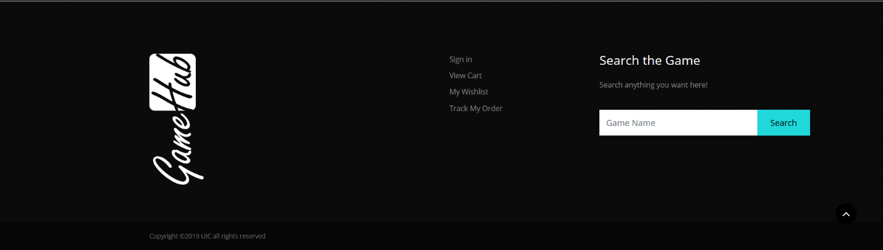

*Figure – 10*

1. 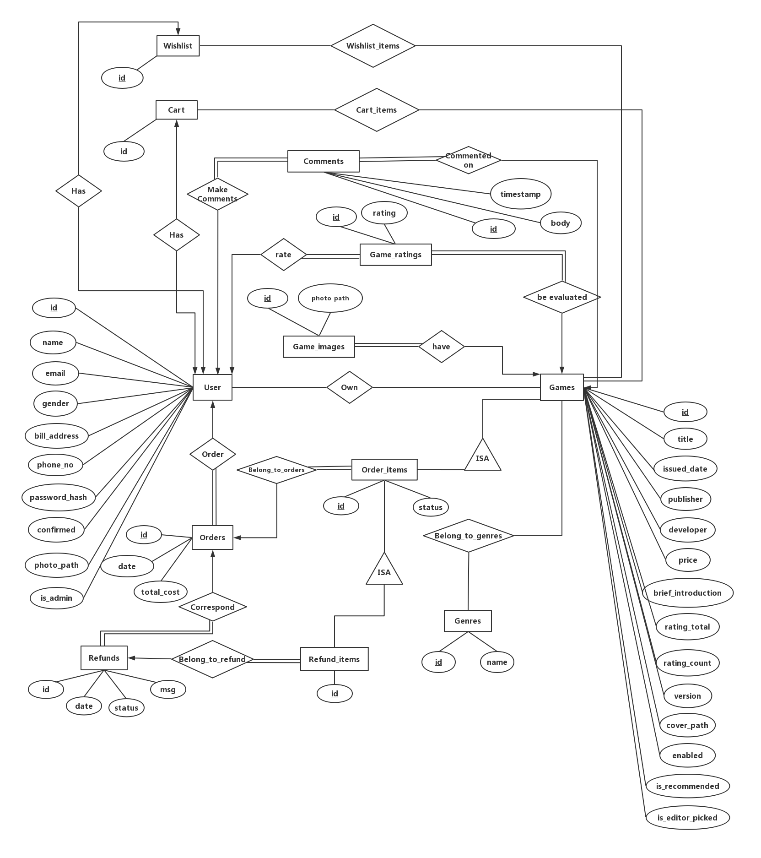Database Design

## ER Diagram

## System objective design

*Game website database management system*

### For the user:

6.1.1.1: *User can view their information through the database*

6.1.1.2: *User can view the game information through the database*

6.1.1.3: *User can view the comments and forum, and the database can also store the comments of the user*

6.1.1.4: *User can view their games they have bought and collect*

### For administrator:

6.1,2.1: *administrator can view the user information in back-stage management*

6.1.2.2: *administrator can view the order information and refund information of the user in order&refund information database*

6.1.2.3: *administrator can view the game information from the game database which include the price, developer, publisher, issued date and so on.*

## Development design philosophy

6.2.1: *Try to use the existing software and hardware environment and advanced management system development plan to achieve the purpose of making full use of existing resources and improving system development level and application effect.*

6.2.2: *The system should comply with the rules of the game website management, meet the daily management needs of the website, and meet the requirements of intuitive, convenient, practical, and safe in the operation process.*

6.2.3: *The system adopts the C/S architecture. The client is responsible for providing the expression logic, displaying the user interface information, and accessing the system analysis. The preliminary work should be as detailed as possible so that the architecture of the website can be changed in the future, and some security requirements are not high. The information can be easily accessed using the Browser/Server method.*

6.2.4: *The system adopts a modular programming method, which facilitates the maintenance and maintenance of technical maintenance personnel who are not involved in the development, even in various combinations and modifications of system functions.*

6.2.5: *The system should have database maintenance functions to add, delete, modify, backup, etc. data according to user needs.*

## Development and run time environment selection

6.3.1: *Development: Mysql 5.7*

6.3.2: *Run-time environment: Windows 10, Windows 8, Windows 7, Windows 98, Windows 95, Mac Os, Android, IOS*

## System function module design

*Based on system function analysis:*

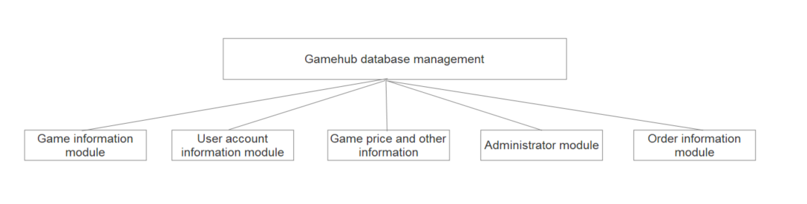

## Database Structure

### Table1: Order information

|  |  |  |  |
| --- | --- | --- | --- |
| *Attribute* | *Data type* | *Null or not* | *Remark* |
| *id* | *INTEGER(11)* | *Not Null* | *primary key* |
| *User_id* | *INTEGER(11)* | *Not Null* | *Client ID* |
| *Date* | *DATE* | *Not Null* | *Order date* |
| *Total_cost* | *FLOAT* | *Not Null* | *Order cost* |

Table 1

### Table 2: Order items

|  |  |  |  |
| --- | --- | --- | --- |
| *Attribute* | *Data type* | *Null or not* | *Remark* |
| *id* | *INTEGER(11)* | *Not Null* | *primary key* |
| *Order_id* | *INTEGER(11)* | *Not Null* | *Order belongs to* |
| *Game_id* | *INTEGER(11)* | *Not Null* | *Game id* |
| *status* | *VARCHAR(30)* | *Not Null* | *The current status* |

Table 2

### Table 3: Refund information

|  |  |  |  |
| --- | --- | --- | --- |
| *Attribute* | *Data type* | *Null or not* | *Remark* |
| *id* | *INTEGER(11)* | *Not Null* | *primary key* |
| *User_id* | *INTEGER(11)* | *Not Null* | *Client ID* |
| *Order_id* | *INTEGER(11)* | *Not Null* | *Corresponding order* |
| *Date* | *DATE* | *Not Null* | *Refund date* |
| *Status* | *VARCHAR(30)* | *Not Null* | *Current status* |
| *Message* | *VARCHAR(200)* | *Not Null* | *Administrator’s message* |

Table 3

### Table 4: Refund item

|  |  |  |  |
| --- | --- | --- | --- |
| *Attribute* | *Data type* | *Null or not* | *Remark* |
| *id* | *INTEGER(11)* | *Not Null* | *primary key* |
| *Refund_id* | *INTEGER(11)* | *Not Null* | *Refund belongs to* |
| *Order_item_id* | *INTEGER(11)* | *Not Null* | *Corresponding order item* |

Table 4

### Table 5: Comments

|  |  |  |  |
| --- | --- | --- | --- |
| *Attribute* | *Data type* | *Null or not* | *Remark* |
| *id* | *INTEGER(11)* | *Not Null* | *primary key* |
| *Game_id* | *INTEGER(11)* | *Not Null* | *Game be commented* |
| *User_id* | *INTEGER(11)* | *Not Null* | *User make comments* |
| *body* | *TEXT* | *Not Null* | *Comment content* |
| *timestamp* | *DATETIME* | *Not Null* | *When the comment is made* |

Table 5

### Table 6: Wishlist

|  |  |  |  |
| --- | --- | --- | --- |
| *Attribute* | *Data type* | *Null or not* | *Remark* |
| *User_id* | *INTEGER(11)* | *Not Null* | *Client ID (Foreign key)* |
| *ID* | *INTEGER(11)* | *Not Null* | *Primary key* |

Table 6

### Table 7: Wishlist content

|  |  |  |  |
| --- | --- | --- | --- |
| *Attribute* | *Data type* | *Null or not* | *Remark* |
| *ID* | *INTEGER(11)* | *Not Null* | *Primary key* |
| *Game_id* | *INTEGER(11)* | *Not Null* | *Corresponding game* |

Table 7

### Table 8: Cart

|  |  |  |  |
| --- | --- | --- | --- |
| *Attribute* | *Data type* | *Null or not* | *Remark* |
| *id* | *INTEGER(11)* | *Not Null* | *primary key* |
| *User_id* | *INTEGER(11)* | *Not Null* | *User belongs to* |

Table 8

### Table 9: Cart item

|  |  |  |  |
| --- | --- | --- | --- |
| *Attribute* | *Data type* | *Null or not* | *Remark* |
| *Cart_id* | *INTEGER(11)* | *Not Null* | *foreign key* |
| *Game_id* | *INTEGER(11)* | *Not Null* | *foreign key* |

Table 9

### Table 10: Game

|  |  |  |  |
| --- | --- | --- | --- |
| *Attribute* | *Data type* | *Null or not* | *Remark* |
| *ID* | *INTEGER(11)* | *Not Null* | *ID(primary key)* |
| *title* | *VARCHAR(100)* | *Not Null* | *Name of the game* |
| *Issued Date* | *DATE* | *Not Null* | *Issued Date* |
| *Publisher* | *VARCHAR(100)* | *Not Null* | *Game publisher* |
| *Price* | *FLOAT* | *Not Null* | *The price of the game* |
| *Developer* | *VARCHAR(100)* | *Not Null* | *Game maker* |
| *Brief_introduction* | *TEXT* | *Not Null* | *Some information* |
| *Rating_total* | *INTEGER(11)* | *Not Null* | *Cumulative rating* |
| *Rating_count* | *INTEGER(11)* | *Not Null* | *No of cumulative rating* |
| *Version* | *VARCHAR(100)* | *Not Null* | *The game version* |
| *Cover_path* | *VARCHAR(256)* | *Null* | *The file path of cover* |
| *enabled* | *TINYINT(1)* | *Not Null* | *Available or not* |
| *Is_recommended* | *TINYINT(1)* | *Not Null* | *Whether on the home page* |
| *Is_editor_picked* | *TINYINT(1)* | *Not Null* | *Whether picked* |

Table 10

### Table 11 : User

|  |  |  |  |
| --- | --- | --- | --- |
| *Attribute* | *Data type* | *Null or not* | *Remark* |
| *id* | *INTEGER(11)* | *Not Null* | *primary key* |
| *Name* | *VARCHAR(100)* | *Not Null* | *User Name* |
| *Gender* | *VARCHAR(1)* | *Not Null* | *F or M* |
| *Bill_Address* | *VARCHAR(200)* | *Null* | *The address of the users* |
| *Personal_Introduction* | *TEXT* | *Null* | *Introduction* |
| *Profile_Picture* | *VARCHAR(256)* | *Not Null* | *File path* |
| *Password* | *VARCHAR(128)* | *Not Null* | *password* |
| *Email_Address* | *VARCHAR(100)* | *Not Null* | *The address of email* |
| *Phone_No* | *VARCHAR(50)* | *Not Null* | *Phone Number* |
| *Confirmed* | *TINYINT(1)* | *Not Null* | *Whether confirmed via email* |
| *Is_admin* | *TINYINT(1)* | *Not Null* | *Is administrator or not* |

Table 11

### Table 12: User_games

|  |  |  |  |
| --- | --- | --- | --- |
| *Attribute* | *Data type* | *Null or not* | *Remark* |
| *User_id* | *INTEGER(11)* | *Not Null* | *Foreign Key* |
| *Game_id* | *INTEGER(11)* | *Not Null* | *Foreign Key* |

Table 12

### Table 13: Game_images

|  |  |  |  |
| --- | --- | --- | --- |
| *Attribute* | *Data type* | *Null or not* | *Remark* |
| *id* | *INTEGER(11)* | *Not Null* | *primary key* |
| *Game_id* | *INTEGER(11)* | *Not Null* | *Foreign key* |
| *Photo path* | *VARCHAR(256)* | *Not Null* | *The file path of photo* |

Table 13

### Table 14: Game_images

|  |  |  |  |
| --- | --- | --- | --- |
| *Attribute* | *Data type* | *Null or not* | *Remark* |
| *id* | *INTEGER(11)* | *Not Null* | *primary key* |
| *name* | *VARCHAR(100)* | *Not Null* | *The name of genre* |

Table 14

### Table 15: Game_genres

|  |  |  |  |
| --- | --- | --- | --- |
| *Attribute* | *Data type* | *Null or not* | *Remark* |
| *Game_id* | *INTEGER(11)* | *Not Null* | *Foreign key* |
| *Genre_id* | *INTEGER(11)* | *Not Null* | *Foreign key* |

Table 15

### Table 16: Game_ratings

|  |  |  |  |
| --- | --- | --- | --- |
| *Attribute* | *Data type* | *Null or not* | *Remarks* |
| *Id* | *INTEGER(11)* | *Not Null* | *Primary key* |
| *Game_id* | *INTEGER(11)* | *Not Null* | *Foreign key* |
| *User_id* | *INTEGER(11)* | *Not Null* | *Foreign key* |
| *Rating* | *INTEGER(11)* | *Not Null* | *Value of rating* |

Table 16

## Schema

### User

*User (id, name, email, gender, bill_address, phone_no, password_hash, confirmed, photo_path, is_admin)*

*User represents the real user in GAMEHUB system.*

*Id: Primary Key of user, used to distinguish each student.*

*Name: The registration name of each user.*

*Email: The email address user used for registration.*

*Gender: The gender of the user.*

*Bill_address: The mailing address of physical bills.*

*Phone_no: The telephone number of each user.*

*Password_hash: The password of the user account.*

*Confirmed: One user account can only operate normally after user clicking the confirming link in the email address he used for registration. Confirmed represents the status whether user has confirmed or not.*

*Photo_path: The file path of user’s profile.*

*Is_admin: The status indicates whether user is an administrator or not.*

### Games

*Game (id, title, issued_date, publisher, developer, price, brief_introduction, rating_total, rating_count, version, cover_path, enabled, is_recommended, is_editor_picked)*

*Games represents the games sold in the GAMEHUB store.*

*Id: Primary Key of game, used to distinguish each game in the system.*

*Title: The name of the game.*

*Issued_date: The date when the game is issued.*

*Publisher: The publisher of the game.*

*Developer: The developer of the game.*

*Price: The price of the game.*

*Brief_introduction: Introduction to the content and characteristics of the game.*

*Rating_total: The cumulative ratings the game has received.*

*Rating_count: The number of ratings the game has received.*

*Version: The current version of the game.*

*Cover_path: The file path of the cover of the game.*

*Enabled: The status of whether the game can be searched and sold in the store.*

*Is_recommended: The status of whether the game is recommended to the home page.*

*Is_editor_picked: The status of whether the game is picked by editor to the home page.*

### Game_ratings

*Game_ratings (id, game_id, user_id, rating)*

*Game_ratings represents the ratings user made for particular games.*

*Id: Primary Key of game_ratings. Id of game_ratings used to distinguish each rating.*

*Game_id: Foreign Key referencing Games. The id of the game be rated.*

*User_id: Foreign Key referencing User. The id of the user makes the rating.*

*Rating: The value of the rating.*

### Game_images

*Game_images (id, game_id, photo_path)*

*Game_images represents the images of the particular games.*

*Id: Primary Key of game_images. The id is used to distinguish each image from each other.*

*Game_id: Foreign Key referencing Game. The id of the game the image belongs to.*

*Photo_path: The file path of the game image.*

### Belong_to_genres

*Belong_to_genres (genre_id, game_id)*

*The n to n relationship set represents that one game can belong to many genres and one genre can have many games.*

*Genre_id and game_id: Primary Key.*

*Genre_id: Foreign Key referencing Genre. The id used to distinguish each genre.*

*Game_id: Foreign Key referencing Game. The id of the game.*

### Genres

*Genres (id, name)*

*Genres represents the types of games in the system.*

*Id: Primary Key of Genres. The id used to distinguish each genre.*

*Name: The name of the genre corresponding to each genre id.*

### Orders

*Orders (id, user_id, total_cost, date)*

*Orders represents the orders users make when they buy games.*

*Id: Primary Key of Orders. The id used to distinguish each order.*

*User_id: Foreign Key referencing User. The id of the user makes the order.*

*Total_cost: The total cost of the items in particular order.*

*Date: The particular date the order is made.*

### Order_items

*Order_items (id, order_id, game_id, status)*

*Order_items represents the particular products one user has purchased in one particular order.*

*Id: Primary Key of Order_items. This id is used to distinguish each item of the order.*

*Order_id: Foreign Key referencing Order. The order_id represents the id of the order the item belongs to.*

*Game_id: Foreign Key referencing Game. The id of the game the item actually is.*

*Status: The status indicates whether the order item is available. (if admin accept the refund request, the game will be no more available for the user to play)*

### Refunds

*Refunds (id, order_id, date, status, msg)*

*Refunds represents the refund requests user made.*

*Id: Primary Key of Refunds. This id is used to distinguish each refund record.*

*Order_id: Foreign Key referencing Order. This represents the corresponding order of the refund request. (One order can correspond to many refunds since that there may be many order items).*

*Date: The specific date the refund is requested.*

*Status: The process status of the refund request.*

*Msg: The message administrator sent to the user when process the refund request.*

### Refund_items

*Refund_items (id, refund_id, order_item_id)*

*Refund_items represents the particular products one user has request a refund in one particular order.*

*Id: Primary Key of Refund_items. This id is used to distinguish each refund item.*

*Refund_id: Foreign Key referencing Refund. The id of the refund the refund item belongs to.*

*Order_item_id: Foreign Key referencing Order_items. The id of the order item(game) the refund item actually is.*

### User_games

*User_games (user_id, game_id)*

*User_games models the relationship set between entity user and entity games.*

*User_id and game_id: Primary Key.*

*User_id: Foreign Key referencing User. The id of the user.*

*Game_id: Foreign Key referencing Game. The id of the game.*

### Comments

*Comments (id, game_id, user_id, timestamp, body)*

*Comments represents the comments user made for the particular games.*

*Id: Primary Key of Comments. This id is used to distinguish each comment.*

*Game_id: Foreign Key referencing Game. The id of the game be commented.*

*User_id: Foreign Key referencing User. The id of the user made the comment.*

*Timestamp: The specific time when user made the comment.*

*Body: The content of the comment.*

### Cart

*Cart (**id, user_id)*

*Cart represents the cart which can store the items which users plan to buy.*

*Id: Primary Key of Cart. This id is used to distinguish each cart.*

*User_id: Foreign Key referencing User. The user_id represents the particular user the cart belongs to.*

### Cart_items

*Cart_items (cart_id, game_id)*

*Cart_items represents the game product included in a particular cart.*

*Cart_id and game_id: Primary Key of Cart_items.*

*Cart_id: Foreign Key referencing Cart. The id of the cart the item should belongs to.*

*Game_id: Foreign Key referencing Game. The id of the game product in the cart which the item actually is.*

### Wishlist

*Wishlist (id, user_id)*

*Wishlist represents the wish list which can store the items which users wish to buy.*

*Id: Primary Key of Wishlist. This id is used to distinguish each wish list.*

*User_id: Foreign Key referencing User. The user_id represents the particular user the cart belongs to.*

### Wishlist_item

*Wishlist_item (wishlist_id, game_id)*

*Wishlist_item represents the game product included in a particular wish list.*

*Wishlist_id and game_id: Primary Key of Wishlist_item.*

*Wishlist_id: Foreign Key referencing Wishlist. The id of the wish list the item should belongs to.*

*Game_id: Foreign Key referencing Game. The id of the game product in the wish list which the item actually is.*

## Functional dependency

### 

*User_id -> name, email, gender, bill_address, phone_no, password_hash, confirmed, photo_path, is_admin*

### 

*Game_id -> title, issued_date, publisher, developer, price, brief_introduction, rating_total, rating_count, version, cover_path, enabled, is_recommended, is_editor_picked*

### 

*Rating_id -> game_id, user_id, rating*

### 

*Image_id -> game_id, photo_path*

### 

*Genre_id -> name*

### 

*Order_id -> user_id, total_cost, order_date*

### 

*Order_item_id -> order_id, game_id, status*

### 

*Refund_id -> order_id, refund_date, status, msg*

### 

*Refund_item_id -> refund_id, order_item_id*

### 

*Comment_id -> game_id, user_id, timestamp, body*

### 

*Cart_id -> user_id*

### 

*Wishlist_id -> user_id*

1. Diagrams













